3-D Printing Robot for Infrastructure Construction

Christian M Chang

Worcester Polytechnic Institute

Abstract

A paper proposing the development of a 3-D printing robot that specializes in construction applications to facilitate construction during the current labor shortage. A 3-D printing robot that is nearly capable as a human construction worker would alleviate a great deal of the shortage that is anticipated in construction labor. Performance measures are verifiable by comparing to metrics of performance by human construction workers.

Keywords: 3-D printing, labor shortage, infrastructure, transportation, housing

3-D Printing Robot for Infrastructure Construction

Need Statement

The Covid era of the late 2010s and early 2020s saw a dramatic focus on labor. Workers that were already beginning to age out of the working world and into retirement decided to call it a career instead of dealing with the remote working world. With an epidemic occurring as the backdrop, younger workers refocused their careers to pursue careers that make them happy. Many workers left the labor market completely for safety reasons. In addition, there were already existing extenuating societal factors such as aging and social pressure to work in glamourous industries. Within this backdrop, many industries scrambled to resolve worker shortages before closing their businesses. This includes the construction industry.

It is evident that the construction industry will soon face a perfect storm in which some work will go undone because there are no workers. The construction industry was estimated to need an additional 650,000 workers in 2022 due to the demands for labor (Associated Builders and Contractors, Inc., 2022). This occurs against the backdrop of a labor environment where almost every industry is facing labor shortages (Bhattarai, 2022). To alleviate construction labor shortages, we propose increasing use of automation to divert human labor from simpler tasks capable by machinery to more complicated tasks that require human capabilities.

Stakeholders

The key stakeholders in this process are parties who need construction labor and do not have it. Construction companies and contractors will be the consumers and have the greatest interest in profiting from the use of these systems. Municipalities and all levels of government agencies are stakeholders as they will benefit from this type of construction accomplished. Representatives from labor agencies, environmental agencies and economic agencies will take an interest in automating construction. Homebuilders and land development companies are stakeholders because residential subdivision construction depends on laborers with knowledge of building homes, drainage channels and roads. Real estate agencies and home buyers and sellers are stakeholders because they will buy, invest in, and live in the products of construction labor robots. The requirement of the stake holders differ yet are sometimes similar.

The construction companies' requirement is for the 3-D printing robot to do slightly less than an equivalent amount of work as a human construction worker. Less is acceptable because there is also value in not paying the typical benefits and costs human workers incur. Also, as the desperation for laborers increases, it is normal for hiring managers to accept less than average employees, and the robot should be considered an acceptable trade off. Municipalities, represented by planners or public works managers have an interest in growing their communities according to their growth plan. Labor agencies and economic agencies representatives will take an interest in expanding job opportunities, safety of works, and increasing economic activity. Environmental representatives will be interested in the effect of automated construction on the environment and waterways. Real estate agencies or other representatives of home buyers and sellers will want to know about the quality, durability, and appeal of the product.

Adversarial stakeholders, or detractors, are expected to strongly object to this system. Those detractors are parties who will immediately be negatively affected by the new system. Labor unions who represent less skilled construction workers will have strong objections to this system. It is a labor union's mission to maintain their members in their line of work and any system that reduces their stature will be fought against. Ironically, another adversary may be the municipalities and various levels of government agencies that stood to benefit before. Depending on political climate, some government agencies may be disinclined to be seen as supporting automation of high paying construction and union jobs.

Operation Concept

There are many scenarios where 3-D printing would augment construction labor and increase speed and production on a construction project. A 3-D printing construction machine would benefit construction projects in many scenarios. In cities where housing costs are increasingly higher, and homelessness is rampant, 3-D printing can be used to print more homes faster and cheaper. Where mass transit is needed because of severe traffic congestion, 3-D printing will alleviate traffic. Structures used in transportation such as bridges, concrete channels, culverts, etc. can be built using 3-D printing. Of course, testing this capability here on earth could have huge payoff when it comes to potential application in space travel, where human labor is limited to the few highest ranked military or former military members capable of commanding or staffing spacecraft. Steps below shows how such a system would operate.

Step 1 - An engineer would communicate to the printing operator what is to be built.

Step 2 - That operator would input those instructions as a design file the printer can read and produce either a structure or a part of a structure from. The structure can be built in situ or off-site and transported and assembled on-site.

Step 3 - On-site operator of 3-D printing system will load design into printer and team will move it into its printing position.

Step 4 - 3-D printer will be prepared for printing with construction material, fuel, power, etc.

Step 5 - 3-D printer will print structure or component per design file.

Operation Requirements

The 3-D printing system's effectiveness as construction labor augmentation can be gauged by various measures. Measure of effectiveness (MOE) is the first measure to use when measuring the system’s capabilities. MOE is derived from the stakeholder’s requirements. MOEs are shown in Table 1.

|  |  |
| --- | --- |
| Stakeholder | Requirement |
| Construction Company | Cost of robot doing the equivalent work of a human laborer is less than the cost of a human laborer |
| Planners or public works managers | Growing their communities according to their growth plan |
| Labor agencies and economic agencies representatives will take an interest in. | Expanding job opportunities, safety of works, and increasing economic activity |
| Environmental representatives | No harm to environment and waterways |
| Real estate agencies | Marketability of this construction method |
| Home buyers and sellers | Marketability and usability of this construction method |
| Transportation Agency | Improvement to infrastructure construction schedule, safety, cost |
| Transportation Customer | Improvement to cost, safety and travel times |

Table 1 Measures of Effectivenss Based on Stakeholder Requirements

The amount of labor dollars a 3-D printing construction robot saves compared to the equivalent amount of compensation the construction laborer would have received. This would still have to be weighed in favor of the printing system because the cost for non-existent laborers would have to increase to attract more workers.

Measures of performance (MOP) measure the characteristics of the system needed for success of the system. For the 3-D printing construction robot there are many measures of success. MOPs are derived from MOEs and the measures are listed in Table 2.

|  |  |
| --- | --- |
| Requirement | MOPs |
| Cost | The cost of robot doing 80% of the equivalent work of a human laborer is less than the cost of a human laborer in a highly competitive labor market; the speed of doing a construction task |
| Schedule or speed of work | The number of construction task the robot can do  Time it takes to reload printing material Number of hours it can operate in a single day and also a working week |
| Construction work | Specification (construction industry standards) the robot is capable of building to, for example can it print 4” sidewalk and switch to 8” concrete driveway  The amount of materials it can construct with |
| Environment | Amount and type of energy the robot uses  Pollution and noise concerns  Leaking materials or fluids  Cleanliness of site after printing is done |
| Real estate sales | Neat, attractive and durable structures  Resellable |
| Home user/ End user needs | Neat, attractive and durable structures  Resellable and livable |
| Transportation Agency project concerns | Faster construction  Less expensive construction |
| Transportation Customer /End user Needs | Faster construction  Lower taxes or toll  Maintainability |

Table 2Measures of Performance based on Stakeholder Requirements

The stakeholder's operational requirements are borne from the previously stated stakeholder's requirements. That is a 3-D printing robot whose output is less than a human is still acceptable. The stakeholder operational requirement is for the 3-D printing robot to perform 80% or higher of the amount of output as an average human construction laborer, for 6 hours a day, in average environmental conditions, for 5 days per work week and 30 weeks of a year. Such an output level will be considered a success.

Functional and Performance Requirements

The functional requirement of the 3-D printing robot is that it constructs homes and infrastructure. When constructing a home, it should build a 1200 square foot house in 1 calendar month. In performing this task, a 1200 square foot home consists of 1 level with a flat roof. The building pad and utility connections will be within the pad already. When used for infrastructure the robot should line 100 linear feet of concrete storm drain channel in 2 working weeks. In performing this task, the channel is 12 inches thick concrete, with a flat bottom and side slopes of 1:1. The channel will slope at 1%.

For a construction company, investors and those who work with construction contractors, the writing on the wall cannot be clearer. Government and transportation agencies trying to stretch revenue for capital improvements and rehabilitation projects will also be cautious about the dwindling labor force available. A robotic 3-D printing construction system will keep projects going now. Important projects like bridge rehabilitations and high-speed rail can continue to be manned by experienced laborers while smaller maintenance type projects can be attended to by robots. As the printing robot improves and their output increases beyond human laborers' output, they will represent a force multiplier for building the most ambitious projects possible. The specter of not having enough construction workers to complete the most important projects of our day is why this 3-D printing construction robot is a worthy investment.

Context Diagram

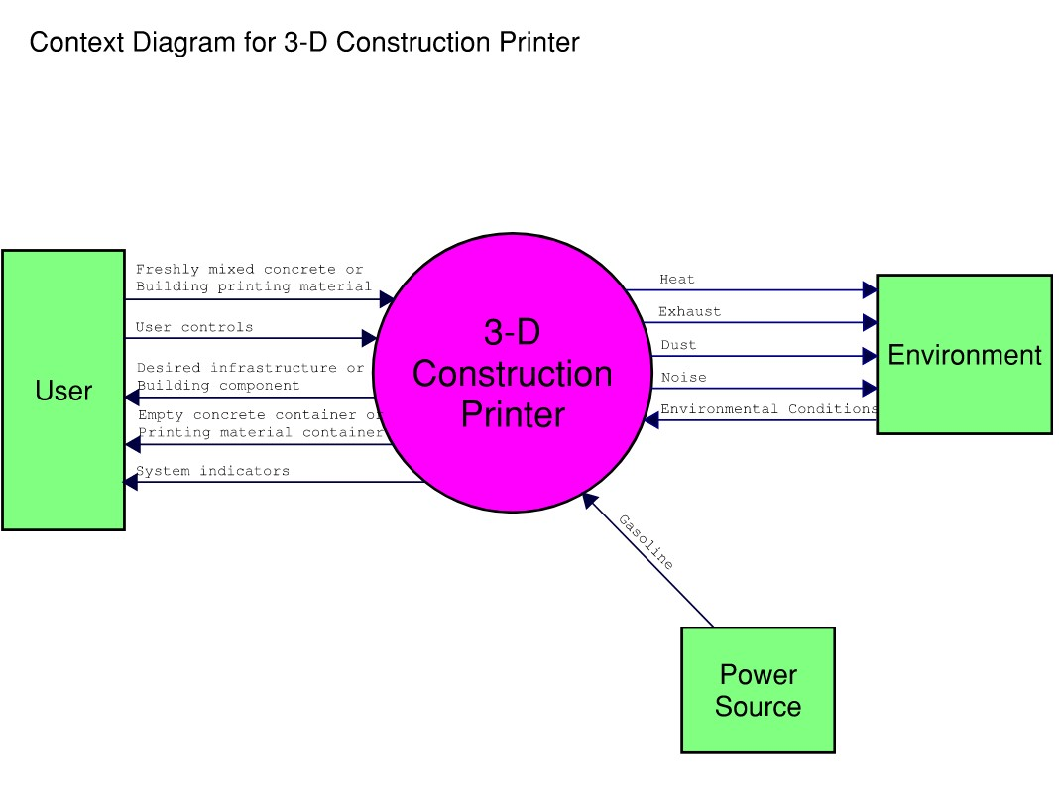

Functional Block Diagram

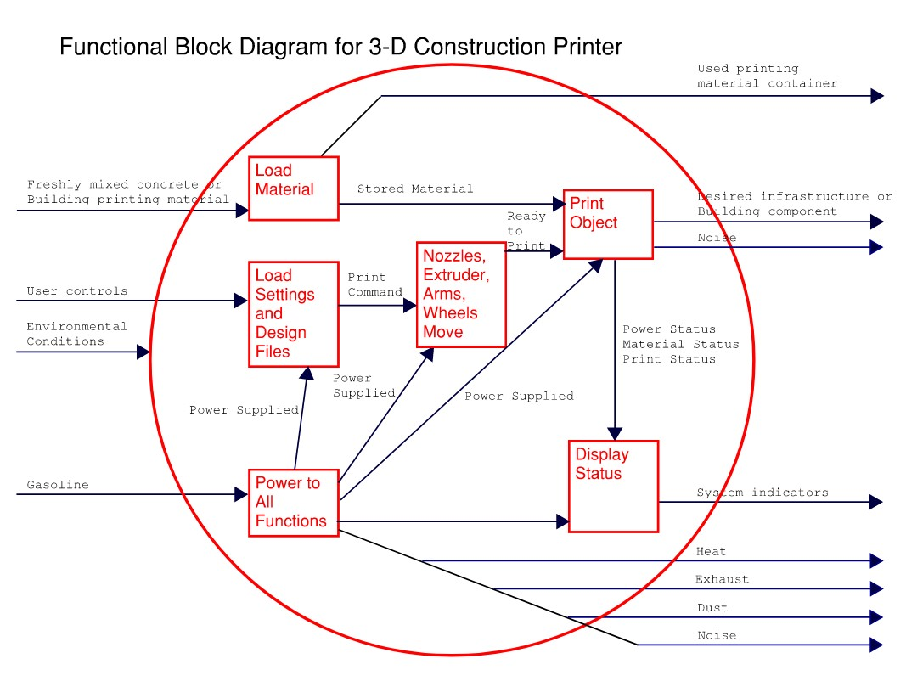

Candidate Architectures

Candidate architectures for the 3-D construction printing robot vary in many ways. In general, increasing cost provides greater complexity, capability, operability, maintainability, and convenience. Table 1 list the architectures in order of increasing cost.

|  |  |
| --- | --- |
| Architecture 1 | The simplest robot. This uses a method similar to contour crafting which is described next (Smith, 2019). This robot operates has 4 columns arranged in a square over a project site. Overhead and within the columns are beams with guide rails built-in to them. These structures must be placed over the area the robot is to print its structure. Nozzles and extruders push the printing material out in the pattern dictated by the design file. The beams, guiderails and nozzles will work their way up the columns as the structure is built layer by layer. When finished the whole architecture will be moved to the next site. |
| Architecture 2 | A more mobile robot than architecture 1. This architecture is more akin to the Metal 3-D method (Smith, 2019). It provides a 6-degree of freedom (DOF) robot arm with a nozzle/extruder at the end. The arm allows for greater detailed work and more elaborate designs. This robot has columns with wheels. The wheels allow the robot to be towed into position, though the wheels are not motorized themselves. |
| Architecture 3 | A wider version of the other architectures. This architecture is more desirable for printing long lengths of structure at a time. For instance, when building wide channels or wide roads, it is desirable to print a long, wide run for consistency and efficiency. Wheels are motorized for greater mobility when repositioning the 3-D construction printer for its next run. |
| Architecture 4 | A 6-DOF robot arm with a nozzle/extruder at the end. The arm is a on a mobile unit consisting of same columns and beam as architecture 3, which is the wider version of the robot. These columns are attached to motorized wheels for mobility. The robot arm can navigate the beam length to reach the location it needs to print. With maximum articulation provided by the robot arm, more complex designs are constructible. The wheels are connected to a controller to give the operator maximum mobility in moving the 3-D construction printer around the site. This robot has future operations capability to build higher structures, such as a second floor, with additional columns and bracing available to extend the capabilities. |

Table 1Possible Architectures for 3-D Construction Printing Robot

Verification

To verify the system methods are employed that provide evidence that the system meets the system requirements. Verification of the system is important because it will ensure that the 3-D construction printing robot can perform the tasks it is designed to perform. The system requirements of the 3-D construction printing robot are that it be able to construct homes and infrastructure. There are further specific requirements for performance. When constructing a home, it should build a 1200 square foot house in 1 calendar month. In performing this task, a 1200 square foot home consists of 1 level with a flat roof. The building pad and utility connections will be within the pad already. When used for infrastructure the robot should line 100 linear feet of concrete storm drain channel in 2 working weeks. In performing this task, the channel is 12 inches thick concrete, with a flat bottom and side slopes of 1:1. The channel will slope at 1%. A roadway can be considered as a type of channel with gentler, gradual, or no slopes, and also a thinner section.

These requirements are specific and lesser performance would not meet the requirements of the system. The verification method for the system should be exact enough to capture how much better or worse the system performs than required. Therefore, the verification methods most suitable to this 3-D construction printer are testing and analysis. These verification methods are the costliest but are necessary for the construction contracting industry. The construction contracting industry works from specifications and thorough analysis of the tools they will implement. Proof that the 3-D construction printer will perform as expected and will increase the value of the product.

For verification of home construction capability, the 3-D construction printer can perform a demonstration. The 3-D construction printer shall be shown building components of a house, such as walls or a roof, and timed as it builds those components. Verification can also be performed by testing the ability to build the whole house as it is timed, per the system requirement. An analysis of the demonstration or test can be performed to breakdown the performance of the system. The analysis can measure how fast the building was printed, which parts were fastest and which parts were slowest to print. A test can also measure how reliably the system performed without interruption, and how much operator attention it required. Operator attention is required for refueling, reloading building material, loading design data, inputting user controls, and maintenance and repairs. The number of operators needed and the number of interactions they have with the 3-D construction printer can be included for analysis.

The infrastructure construction requirement of the system can be verified similarly as the home construction verification method.

Validation

Validation of the system provides evidence that the system will achieve the intended use. Validation answers a more general question than verification does. When verifying we are affirming that the completed system is meeting the system requirements for function and performance. Validation ensures that these verified system requirements accomplish the goal of the stakeholders.

The stakeholder requirements were previously determined. The construction companies' requirement is for the 3-D printing robot to do slightly less than an equivalent amount of work as a human construction worker. Less is acceptable because there is also value in not paying the typical benefits and costs human workers incur.

To validate the system the MOEs will be tested during validation. The designer of the system will self-certify because there is no current certifying agency for this type of system. Since self-certification is not enough to reassure a customer of the validated results, further qualification will be done in the field to assist the construction contractor to utilize the system. The system will further be warranted to perform to the specifications for a limited amount of time during which the system designer will take responsibility for defects in the design or fabrication of the unit, but not for contractor's misuse of the system.

To assist the validation of the system and ensure the system is meeting the requirements, data will be stored on the printer system and shared with the designers. The data will be analyzed to determine the system has achieved cost goals and performance goals.

Operation & Maintenance

During the operation process the 3-D construction printer will be used in accordance with CONOPS. During operation, all enabling systems shall be ready for the 3-D construction printer to operate as intended. There are many enabling systems needed for the 3-D construction printer to begin and continue to operate, and also before ending daily operations. Examples of enabling systems include:

1. Trained operators and training and operating documents
2. Tools including computers with design files and design systems which are necessary to give instruction to the printer shall be available and accessible
3. Fuel supply shall be ready to provide continuous power for the printer
4. Printing material supplies shall be stored or delivered and ready to load to printer as necessary

Maintenance of the system is of utmost importance because of the risk of the printer mechanisms failing due to improper maintenance. There are many moving parts in the system, including sprayers, extruders, and components under pressure. Persons will be trained and designated to maintain the 3-D construction printer on a daily/weekly/monthly basis as required. Water and cleaning supplies to thoroughly clean the printer and keep it operational shall be accessible and used before shutting down the printer after operations are complete for the day or as frequently as prescribed by the operation documents. For parts prone to wear and tear follow example prescribed maintenance schedule, weekly, monthly, or changing wheels after a certain number of miles traveled. The manufacturer of the 3-D construction printer shall be responsible when the 3-D construction printer does not operate as expected and all operation procedure and maintenance has been followed.

3-D Printing Robot for Infrastructure Construction

Christian M Chang

Worcester Polytechnic Institute

Decision Management

With several candidate architectures to choose from a decision is required to select an architecture. Using the decision management process we will analyze and evaluate the alternative architectures in a structured way which will explain why we chose the final architecture. The decision management process will make use of the analysis of alternatives method of evaluating alternative choices and making a decision.

In analysis of alternatives (AoA) we will the choices of architectures and ideally identify the best one. If the best one cannot be identified than the best choices among all the choices should be identified. We will also choose dimensions to compare the alternatives. A dimension is a quality of the architectures that can is measured from all the choices. The best architecture should be picked when the qualities of each alternative can be analyzed and evaluated.

The AoA begins with the information we have on the candidate architectures 1-4, which is given previously in the candidate architecture section. Firstly we eliminate any non-viable alternatives, and any alternatives that are not cost effective. Architectures 4 will be eliminated because it is too costly and too risky to create this technology. Architecture 1 will also be eliminated because it is similar to other architectures and does not provide enough value to the customer. The remaining architectures are architecture 2 and 3, as shown in Figure 1.

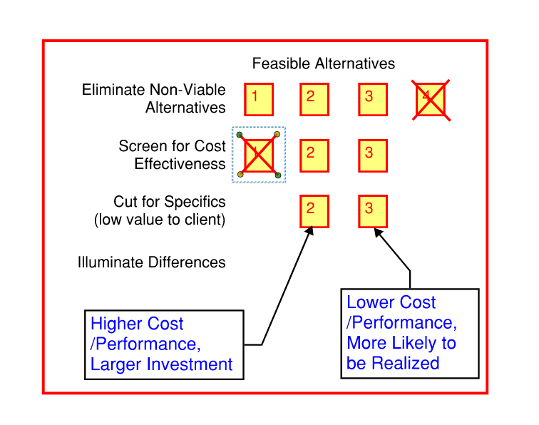

Figure 1Eliminating Candidate Architectures

Architectures 2 and 3 are then evaluated for their differences in effectiveness, cost, and risk. Architecture 2 is much more effective than Architecture 3. However the cost of the parts as well as the cost of developing the technology for the 3-D construction printer are much higher than architecture 3. The difference in risk, which is again attributable to the investment in developing new technology, is shown in Figure 1. Based on this analysis the preferred architecture is architecture 3.

Configuration Management

Configuration management is important to the 3-D construction printer because through configuration management we will establish, manage and control the baselines of the system. The baselines are the business, budget, functional, performance, and physical reference points of the system. For the 3-D construction printer, the important reference points are business, functional, performance, and physical.

The business reference point of the 3-D construction printer system is that it is essentially a construction tool used to augment construction labor. Deviations from this reference point will need to be managed by the configuration managers to determine if there is another business use for the system. Configuration managers will determine what, if any, changes to the system are required to accommodate a change in the baseline.

The functional reference point of the system is that is printing houses, and specific types of infrastructure previously identified. The 3-D construction printer also functions by accepting design files that utilize a 3D printer standard format for printing, and in no other way. There are no controls that enable building without a design file, and design files cannot be altered using the unit. This is important to prevent any possibility of structural designs being altered without the knowledge of their designers. If the 3-D construction printer designers wish to change the function of the system and deviate from these reference points, the configuration managers shall approve this.

The performance reference points have been previously stated when discussing the expected acceptable performance of the system (MOP) and the performance required by the stakeholders (MOE). These performance reference points include the speed at which the 3-D construction printer works, the length of time it performs work, etc. These performance reference points shall be adhered to in the design of the 3-D construction printer. Changes to the performance below or beyond that previously established should be reviewed by the configuration managers and approved.

The physical reference point such as how the system looks or is put together is an important baseline. The system should be configured to be just the printing component of the contractor's larger system. It is not like a bread machine where all the ingredients are poured in and a loaf of bread is produced. The printer can accept printing material supplied by the contractor in the way specified by the system. However the 3-D construction printer does not mix or produce printing material or transport it or verify the suitability of the material. This is an important baseline and deviations from it will be significant.

All deviations from the configuration shall be done only after obtaining approval from the configuration managers. Engineering change proposal (ECP) shall be provided to the configuration managers to request approval of a configuration change.

Information Management

Information management will present several challenges during the project. The purpose of information management is to maintain an archive information produced throughout the lifecycle of the system. The first challenge of the archive will be to keep the development documents of the system secure. Since these are the founding documents on which the entire project is based, they will have to be secured electronically, with limited access to only the system engineers and stakeholders and whoever they determine can see the documents. This challenge will likely be solved by the information technology specialists of the company that can secure files and limit access in the server.

The next challenge will be providing access to files for the designers of the system. Engineers will need access to drawings and models, as well as software code in order to complete the design of all the sub-systems. There may only be limited access to the files across disciplines, to avoid accidentally damaging other designers' works. This challenge will likely also be addressed by design specialists who best know how to organize and protect their work.

A third information management challenge is storing data files from the system life cycle. Current information will these have to be stored and be accessible immediately. There should be remote access and access from the staff offices. Remote access should be secure. Information in the computer systems and servers should be backed up on a regular basis to a back-up storage system in case the files in the primary system or lost or older versions are needed. This challenge will likely be addressed with information back-up systems that can archive data for long term storage.

The final information management challenge is collecting and securing shared data from customer’s systems. Part of the continuing validation process is to collect data from customers systems that are in use. This data is used to validate the system has met the requirements of the customer in terms of cost and performance. Since this data may constitute trade secrets of the customer it must be kept secure and have limited access. This challenge can be addressed by third party information system security, or using information systems stored in secure locations in the reputable cloud services that can assure security of the information. In addition the information specialists of the organization can limit access to this data.

Measurement

During the measurement process data is collected, analyzed and reported which demonstrates the 3-D construction printer satisfies the technical requirements. Methods to measure that the 3-D construction printer meets the MOP must be devised. By measuring the performance of the 3-D construction printer we can determine if the system meets the performance requirements.

MOP were previously shown in table 2 of the Operation Requirements section. Methods will be employed to measure each of the MOPs. By satisfying the MOPs the MOEs will also be satisfied, since the MOPs were derived from the MOEs.

Cost will be measured by a summation of the cost of materials and labor to build the unit, plus a built in cost per unit for the design, maintenance, and profit, as is standard in the construction industry and the technological hardware industry.

Speed of work will be measure by timing the performance of the 3-D construction printer as it performs tasks it will be expected to do in the field. Time it typically takes to load materials into the printer will be measured. To measure the number of hours the unit can operate, the specifications of the parts used to build the unit will be taken into account. These parts have a specified time before they fail during normal activity, and those times will be analyzed and revised to take into account the activities of the 3-D construction printer.

The specification the robot builds to will be measured by passing or failing to perform a task that meets the code. If the printer is capable of performing the task to code, then the 3-D construction printer can be said to be in compliance with the code.

The amount of materials is composed of the number of materials that the printer can print and perform and meet all performance requirements. Any limitations will be noted as not all materials are suited to all manners of use (e.g. it is not possible nor advisable to build a reinforced sloped storm water channel out of resin or gypsum.

The amount of energy the robot uses will be measured by the gallons of gas or diesel it takes for the system to perform continuously for an hour/8-hour day.

Pollution and noise concerns can be measured in various ways. The amount of air pollution a motor generates as it consumes gasoline for mechanical and electrical energy is measured by standard industry measures already recognized in the motor building discipline. Noise concerns can be measured with a sound level meter using construction industry standard metrics and OSHA standards for worker safety.

Cleanliness of a construction site is typically the domain of the construction crew, but by using industry standard and better for hoses and parts that move fluid, leak free operation can be assured.

Building neat attractive and durable structures depends on the detail of construction the 3-D construction printer is capable and the material it is using for structures. The 3-D construction printer will be designed to use the latest advances in material sciences for durable and attractive materials. The level of detail of construction will be measured using similar measures as tabletop or office 3D printers, except applied to construction methods which will likely have lower levels of performance.

These measurement methods are summarized in table 1. Implementation compliance provides proof to the stakeholders that the performance of the system meets the technical measures.

|  |  |  |
| --- | --- | --- |
| Requirement | MOPs | Measurement Method |
| Cost | The cost of robot doing 80% of the equivalent work of a human laborer is less than the cost of a human laborer in a highly competitive labor market; the speed of doing a construction task | Summation of the cost build and design the unit, profit |
| Schedule or speed of work | The number of construction task the robot can do  Time it takes to reload printing material Number of hours it can operate in a single day and also a working week | -Timing the performance of the printer, and time it typically takes to load materials into the printer will be measured.  -Measure the number of hours the unit can operate based on specifications of the parts |
| Construction work | Specification (construction industry standards) the robot is capable of building to, for example can it print 4” sidewalk and switch to 8” concrete driveway  The amount of materials it can construct with | -Specification the robot builds to will be measured by passing or failing to perform a task that meets the code  -The number of materials that the printer can print with |
| Environment | Amount and type of energy the robot uses  Pollution and noise concerns  Leaking materials or fluids  Cleanliness of site after printing is done | -Measured by the gallons of fuel it takes to perform continuously for an hour/8-hour day.  -Measuring the amount of air pollution motor generates  -Measuring noise using construction industry standard metrics and OSHA standards for worker safety  -Cleanliness measure in rating of parts, better than industry standard, to avoid leaks |
| Real estate sales | Neat, attractive and durable structures  Resellable | Measured as “resolution” or fineness of printer’s work |
| Home user/ End user needs | Neat, attractive and durable structures  Resellable and livable | Measured as “resolution” or fineness of printer’s work |
| Transportation Agency project concerns | Faster construction  Less expensive construction | Combination of previous measures |
| Transportation Customer /End user Needs | Faster construction  Lower taxes or toll  Maintainability | Combination of previous measures |

Table 1 Methods to Measure MOPs

Quality Assurance

Quality assurance during the project life cycle consists of the preventative measures the project takes to assure the project meets stakeholder requirements and adheres to established methodology.

There are several methods the 3-D construction printer project team will utilize to provide quality assurance. The first is to create and adhere to checklists of the MOPs, key parameters, and technical measures. The goal is for the team to understand what measurements will be taken at the end of the design and ensure that the team knows they must meet the requirements. Designs that cannot assure they meet the requirements will be returned for correction.

Quality audits are another way of assuring quality. When checklists are turned in they are to be turned in with the documentation that proves the design meets the technical measure. Documentation that inadequately supports the checklists or improperly filled out checklists will be returned to the project team for correction.

Problems during the project lifecycle will be solved by two methods. The root cause method will be used to solve underlying defects or anomalies in the project.

Root cause method has several approaches to resolve defects in the project. The 3-D construction printer project will likely use the five whys method to resolve issues.

The five whys technique is a method to resolve problems in the project. When a problem present's itself the team setting out to solve the problem will "transform the problem into a why question" (Kohfeldt, 2012). When an answer is determined, the team will turn that answer into a why, and repeat this until why has been asked 5 times. This method ensures that "unsubstantiated assumptions" are removed from the solution to the problem, ensuring a better solution.

Risk Management

Risk management is the method by which problems during the project life cycle are identified, analyzed, treated, and monitored.

Risk 1 - If 3-D construction printer cannot be ready for delivery by end of next winter, then sales ahead of spring/summer construction season will be missed.

Risk 2 - If political pressure, or bad press grows against system, then construction contractors may be reluctant to utilize system.

Risk 3 - If safety isn't considered in design, then construction accidents may occur.

Risks to the project are shown in table 2 below. A risk matrix is shown in table 3 as a visual aid to understanding the risks.

|  |  |  |  |
| --- | --- | --- | --- |
| Risk | Impact | Likelihood | Mitigation |
| 3-D construction printer cannot be ready for delivery by end of next winter, sales for construction season will be missed | Schedule | Likely | Direct more resources to task that can be done faster |
| Political pressure, or bad press grows contractors may be reluctant to utilize system | Cost | Likely | Increase marketing, public relations budget |
| Safety hazards creating an accident | Technical | Near-Certain | Review design for safety, include more hazard lights, warning sounds, and emergency buttons |

Table 2 Risk Mitigation

|  |  |  |  |  |  |  |
| --- | --- | --- | --- | --- | --- | --- |
| Impact Severity | Catastrophic |  |  |  | **2** | **3** |
| Critical |  |  |  | **1** |  |
| Moderate |  |  |  |  |  |
| Marginal |  |  |  |  |  |
| Negligible |  |  |  |  |  |
|  | | Rare | Unlikely | Possible | Likely | Near-Certain |
| Likelihood | | | | |

Table 3 Risk Matrix

Besides risk, there are also opportunities for the project.

If nozzles and extruders can be improved upon, then opportunity to improve 3dcp to use hot mixed materials arises. Hot mix materials are popular in construction therefore the value of the printer increases with this capability

If 3-D construction printer can be ready with a running model before end of current spring/summer, opportunity to perform field demonstrations will arise.

Opportunities to the project are shown in table 4 below.

|  |  |  |  |
| --- | --- | --- | --- |
| Opportunities | Impact | Likelihood | Capture Plan |
| If nozzles and extruders can be improved upon, then there are more printing material options | Technical | Likely | Use different material for nozzles/extruders are provide capability thru redesign |
| If working 3-D construction printer can be ready before end of current spring/summer, then can perform field demonstrations | Schedule | Possible | Direct more resources to task that can be done faster or demonstrate a model with less capabilities |

Table 4 Opportunity Capture Plans

References

Associated Builders and Contractors, Inc. (2022). Construction Industry Faces Workforce Shortage of 650,000 in 2022. https://www.abc.org/News-Media/News-Releases/entryid/19255/abc-construction-industry-faces-workforce-shortage-of-650-000-in-2022

Bhattarai, Abha. (2022). Worker shortages are fueling America’s biggest labor crises. https://www.washingtonpost.com/business/2022/09/16/worker-shortage-strikes-economy/

Khan, Sanchez, F., & Zhou, H. (2020). 3-D printing of concrete: Beyond horizons. Cement and Concrete Research, 133, 106070–. <https://doi.org/10.1016/j.cemconres.2020.106070>

Kohfeldt, & Langhout, R. D. (2012). The Five Whys Method: A Tool for Developing Problem Definitions in Collaboration with Children. Journal of Community & Applied Social Psychology, 22(4), 316–329. https://doi.org/10.1002/casp.1114

National Academy of Engineering. (2022). Grand Challenges for Engineering. http://www.engineeringchallenges.org/

Smith. (2019). 3-D Printing Reshaping Construction Industry. Design Cost Data, 63(5), 10–10.

Witte, Oliver. (2014). 3-D Printing for Construction? The next Best Thing Is out There and Waiting for Developers. Rural Builder, vol. 48, no. 7, p. 57.

Wu, Peng, et al. (2016). A Critical Review of the Use of 3-D Printing in the Construction Industry. Automation in Construction, vol. 68, pp. 21–31. <https://doi.org/10.1016/j.autcon.2016.04.005>.